CREATING LPAR AND CONFIGURING NPIV , STEP BY STEP LPAR CONFIGURATION AND NPIV , STEP BY STEP VIRTUAL FC IN VIO
ALL DOCUMENT ARE PROPERTY OF SHIVAKANT , DO NOT COPY IBM , AIX , HACMP , ARE REGISTERED TRADE MARK OF IBM
STEP BY STEP TO CONFIGURATION OF LPAR AND NPIV
CREATE A LPAR
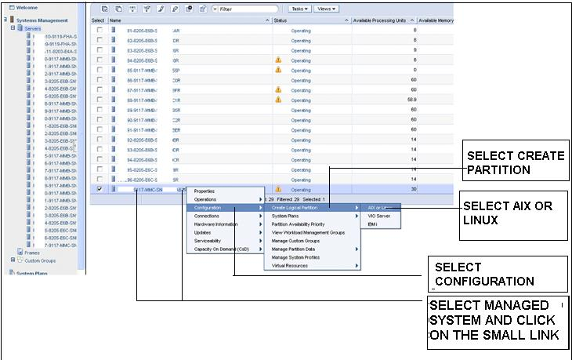

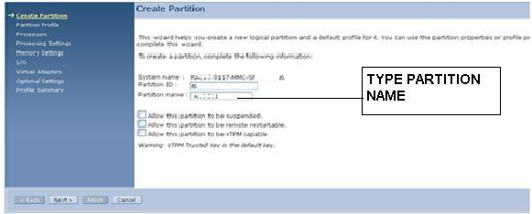

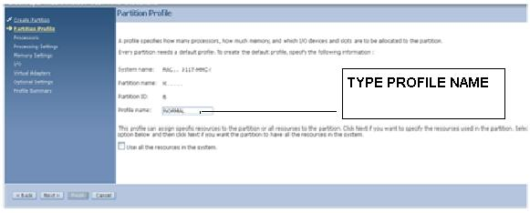

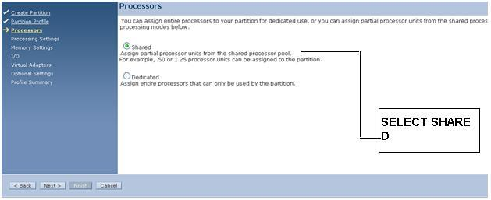

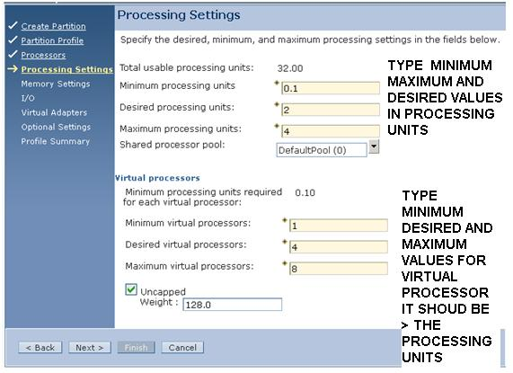

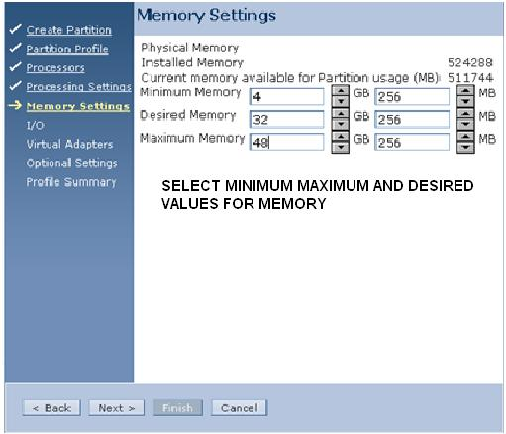

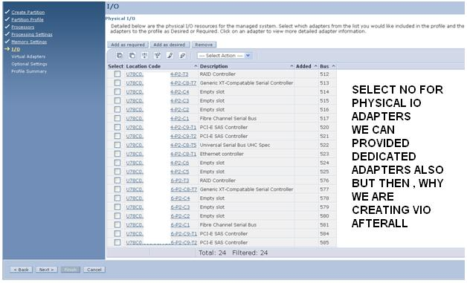

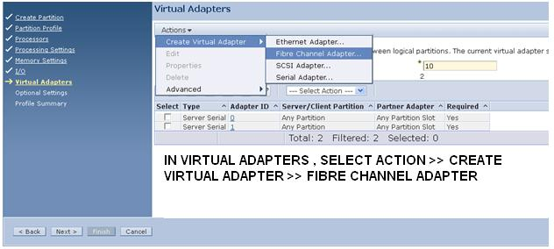

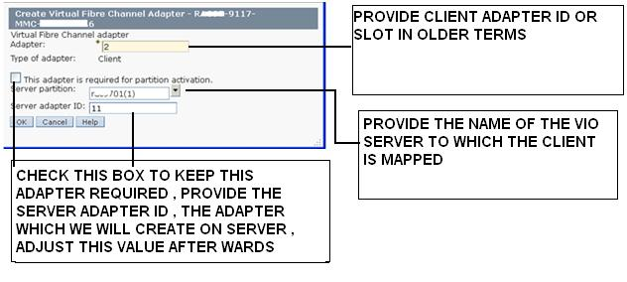
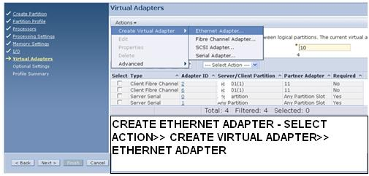

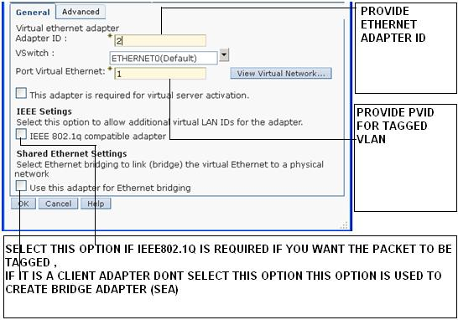

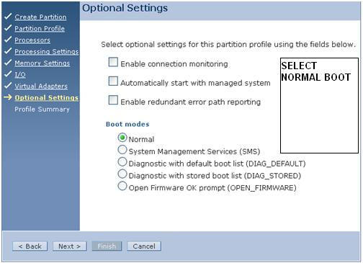

COMPLETE SERVER SIDE CONFIGURATION

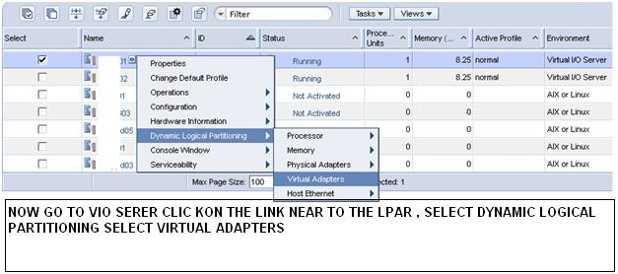

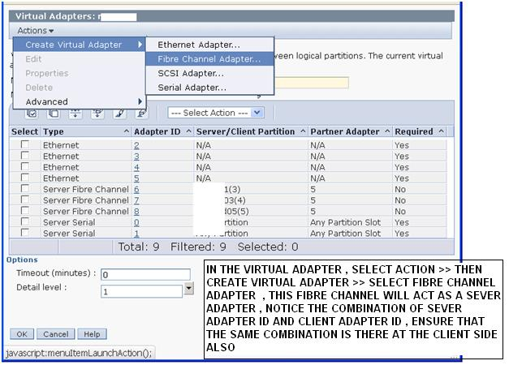

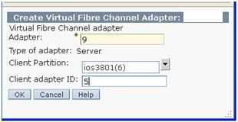

AFTER CREATING THE LPAR GOTO THE VIO SERVER AND RUN

$ cfgdev

YOU WILL GET THE NEW VIRTUAL HOST

VIEW THE NEW ADAPTER BY THE COMMAND BELOW
$ lsdev -type adapter
vfchost3 Available Virtual FC Server Adapter
vsa0 Available LPAR Virtual Serial Adapter

VIEW THE ADAPTERS AND THEIR MAPPINGS BY THE COMMAND BELOW
$ lsmap -all -npiv

Name Physloc ClntID ClntName ClntOS
------------- ---------------------------------- ------ -------------- -------
vfchost3 U9117.MMC.06BBBA6-V1-C9 6

Status:NOT_LOGGED_IN
FC name: FC loc code:
Ports logged in:0
Flags:1<NOT_MAPPED,NOT_CONNECTED>
VFC client name: VFC client DRC:
NOTE THAT THE VIRTUAL ADAPTER IS NOT MAPPED WITH ANY FIBRE CHANNEL ADAPTER

MAP THE VIRTUAL ADAPTER WITH PHYSICAL ADAPTER BY THE FOLLOWING COMMAND

$ vfcmap -vadapter vfchost3 -fcp fcs0
$ lsmap -npiv -vadapter vfchost3
Name Physloc ClntID ClntName ClntOS
------------- ---------------------------------- ------ -------------- -------
vfchost3 U9117.MMC.06EBBB6-V1-C9 6

Status:NOT_LOGGED_IN
FC name:fcs0 FC loc code:U78C0.001.DBJT494-P2-C1-T1
Ports logged in:0
Flags:4<NOT_LOGGED>
VFC client name: VFC client DRC:
NOTE THAT THE VIRTUAL ADAPTER IS MAPPED WITH FIBRE CHANNEL ADAPTER FCS0

